**Liver Cirrhosis Prediction Report**

**Introduction**

This code performs an end-to-end analysis of a liver cirrhosis dataset. It loads, cleans, and preprocesses the data, including categorical encoding and feature scaling. It visualizes the data using regression plots, bar plots, and confusion matrix heatmaps. Finally, it trains, evaluates, and compares Logistic Regression, KNN, and Random Forest models.

**Dataset Analysis**

* **Dataset Source:** The dataset is obtained from a CSV file that contains records related to liver cirrhosis. It includes various features such as patient demographics, clinical measurements, and diagnostic outcomes.
* **Initial Preprocessing:** Before analysis, the dataset undergoes essential preprocessing steps. This involves handling missing values, converting categorical data to numerical formats, and scaling numeric features to ensure that all variables are on a comparable scale.
* 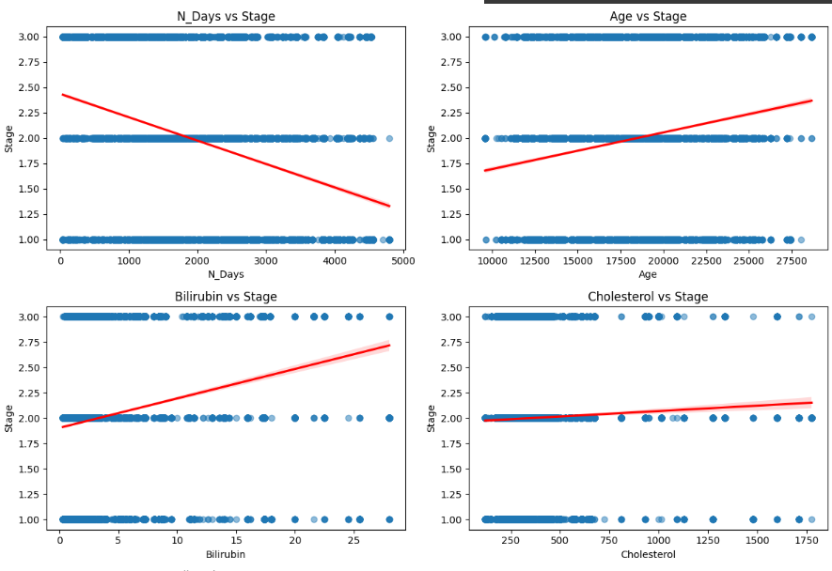**EDA:** Exploratory Data Analysis (EDA) is conducted to gain insights into the data structure and quality. This phase includes examining the column names, dataset shape, and basic statistics, as well as visualizing relationships and distributions through regression plots and correlation heatmaps.

**Data Visualization**

* **Regression Plots:** These plots depict the relationship between each numeric feature and the target variable. They are useful for identifying trends, potential outliers, and the strength of correlations between predictors and the outcome.
* **Bar Plots:** By visualizing the distribution of categorical variables, the bar plots help in assessing the balance of classes and detecting any irregularities or imbalances in the data that may need addressing during preprocessing.
* **Model Comparison and Confusion Matrix Heatmaps:** A bar plot is used to compare the accuracies of different models, offering a clear and immediate visual summary of performance. In addition, confusion matrix heatmaps for each model provide a detailed look at classification results, highlighting true positives, false positives, and misclassifications, which aids in a deeper understanding of each model's strengths and weaknesses.

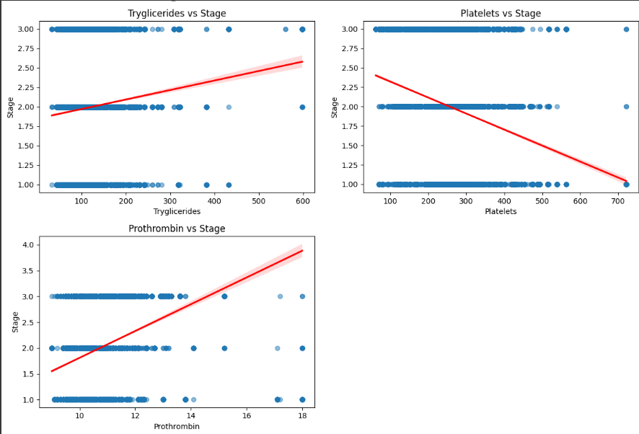

**Dataset Preprocessing**

* **Missing Value Handling:** Missing data is addressed using a forward-fill strategy, ensuring continuity and reducing the risk of data loss.
* **Categorical Data Conversion:** Categorical features are transformed into numerical values via one-hot encoding, making them compatible with machine learning models.
* **Feature Scaling:** Numeric features are standardized using StandardScaler, ensuring that all variables contribute equally during model training.

**Model Implementation and Evaluation**

* **Data Splitting and Model Training:** The pre-processed dataset is divided into training and testing sets. Three different models—Logistic Regression, KNN, and Random Forest—are implemented with carefully chosen parameters to ensure robust learning.
* **Performance Evaluation:** Each model's predictions are evaluated using metrics such as accuracy, confusion matrices, and classification reports, providing a quantitative measure of performance.
* **Visualization of Results:** Bar plots compare the overall model accuracies, while confusion matrix heatmaps offer detailed visual insights into the true positives, false positives, and overall classification performance for each model.

**Confusion Matrix**

Heatmaps of confusion matrices provide an intuitive visual summary of a classification model's performance. Below are few key points:

* **Visual Clarity:** The heatmap uses color intensity to represent the frequency of predictions. Darker shades typically indicate higher counts, making it easier to spot where the model is performing well (i.e., along the diagonal where true positives reside) versus where it is making mistakes.

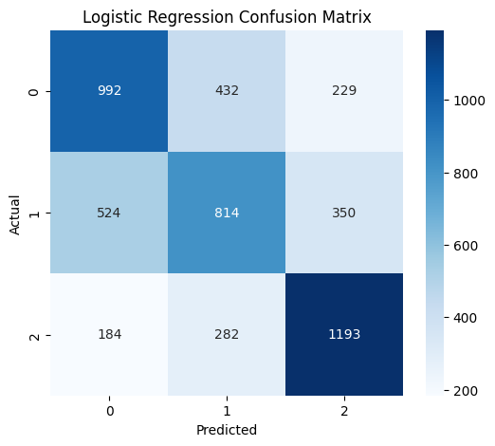

* **Error Analysis:** Off-diagonal cells reveal misclassifications, helping to identify specific areas where the model may be confusing one class with another. This insight is valuable for further model tuning or data refinement.

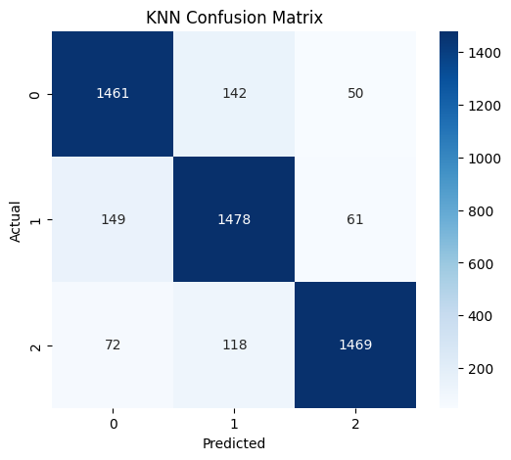

* **Comparative Assessment:** When multiple models are evaluated, heatmaps provide a quick, side-by-side visual comparison of their confusion matrices, allowing for an effective assessment of which model better differentiates between classes.

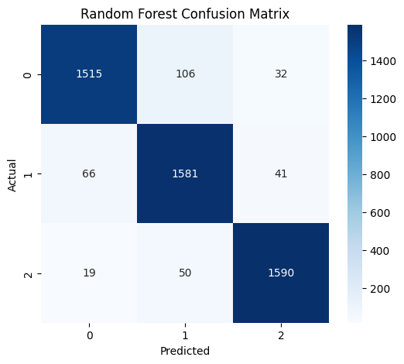

**Prediction and Result**

* The models make predictions on a held-out test set after being trained on the preprocessed data.
* Performance is quantified using metrics such as accuracy, confusion matrices, and detailed classification reports.
* Visual outputs, including bar plots, provide a clear comparison of model accuracies.
* Heatmaps of the confusion matrices offer an intuitive visualization of correct and incorrect predictions.
* The combined results facilitate an effective evaluation of each model's strengths and weaknesses

**Model Comparison**

A bar plot is used to compare the performance of the models based on accuracy:

* KNeighbors Classifier, Logistic Regression, and Random Forest Classifier are evaluated.
* Random Forest appears to outperform the others in terms of accuracy, followed by KNN and Logistic Regression respectively.

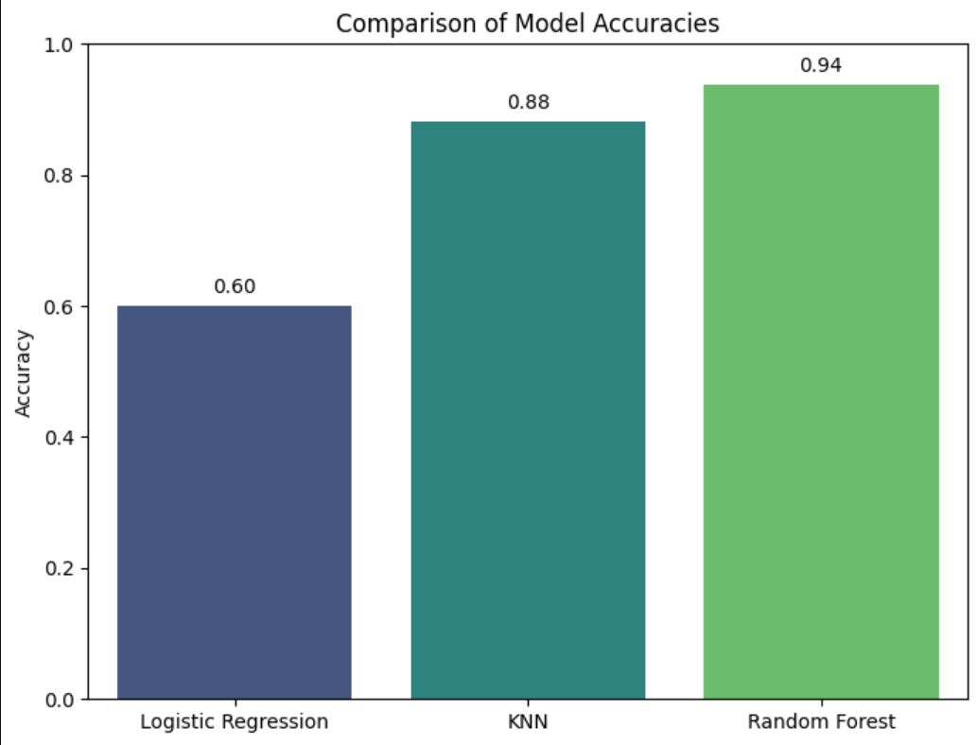

**Conclusion**

The project successfully demonstrates the prediction of liver cirrhosis stages using machine-learning models. The Random Forest model is the best-performing model in this experiment.